Kristy Armstrong dies in Molong crash as NSW Police probe domestic violence
A NSW mother-of-three was allegedly being pursued by her estranged husband when she died in a shocking car crash.
Clementine CuneoExclusive
June 11, 2023 - 3:51PM
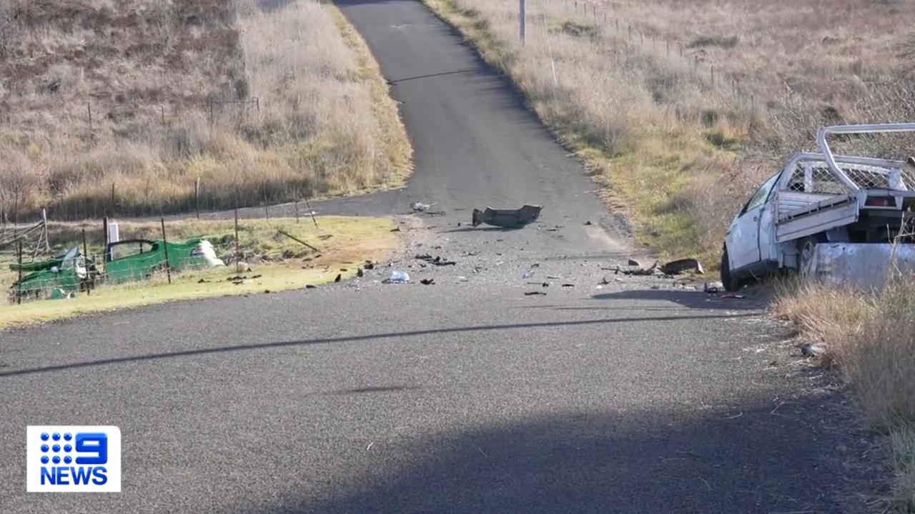
Kristy Armstrong died in the crash at Molong on Friday. Picture: 9 News

Police & Courts
Don't miss out on the headlines from Police & Courts. Followed categories will be added to My News.
Follow
Two weeks after an apprehended violence order was granted by a court, a mother-of-three was allegedly pursued to her death by her estranged husband - the man banned from going near her.
Kristy Armstrong, 36, died instantly when her car ran off the road and crashed at Molong, in the state’s central west, on Friday.
Her two older daughters, aged 8 and 13, were in the car and suffered minor physical injuries.
Metres from Mrs Armstrong’s wreckage was the mangled utility of her estranged husband Troy Armstrong which police said crashed into her before coming to rest along the roadway.
Kristy Armstrong, 36, died in a tragic crash at Molong on Friday. Picture: Facebook
Mr Armstrong, 35, a retained firefighter in the region, was pulled from his vehicle in a critical condition and flown to Royal North Shore Hospital in Sydney, where he remains in a serious condition, under police guard.
NSW Police have launched a major domestic violence investigation, with the help of the homicide squad, after witnesses claimed they overheard the pair screaming at each other outside their children’s primary school, before they both left in separate cars.
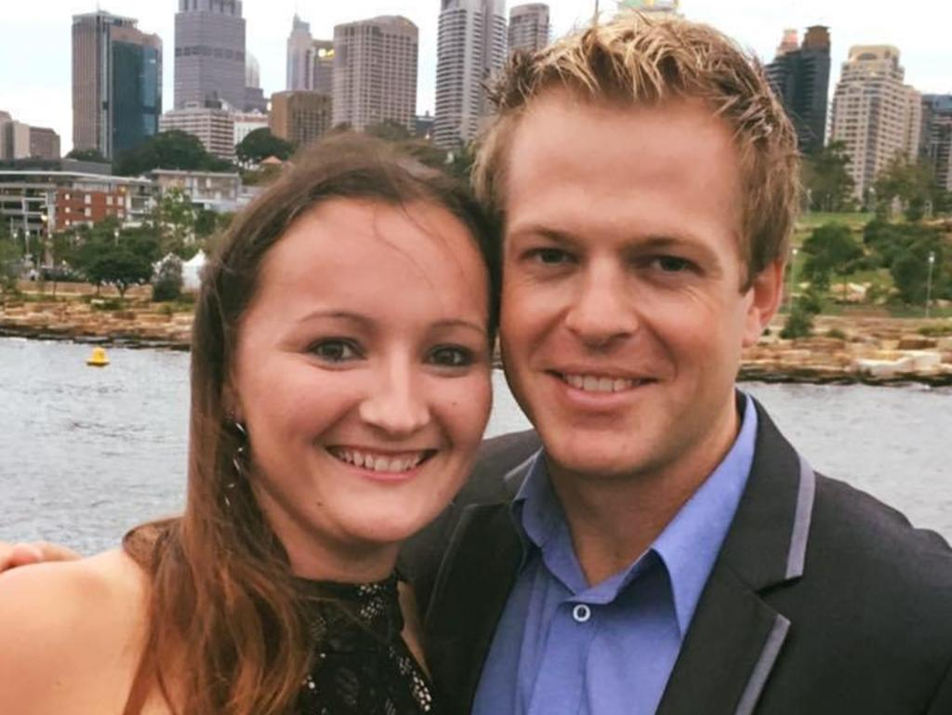
Kristy Armstrong and her estranged husband Troy Armstrong pictured before they separated in 2022. Police said Mr Armstrong was pursuing his former wife’s car when she fatally crashed on Friday. Picture: Facebook
About 30 minutes later, at 3.40pm, the two cars collided on Speedy St near the Mitchell Highway intersection, and Mrs Armstrong was killed instantly.
The Daily Telegraph can reveal that on May 25, the estranged couple both appeared in Orange Local Court at a hearing where an AVO was granted in protection of Mrs Armstrong.
Court documents revealed Mrs Armstrong first applied for an AVO against Mr Armstrong in November last year, around the time the pair separated, and an interim order was issued until the hearing last month.
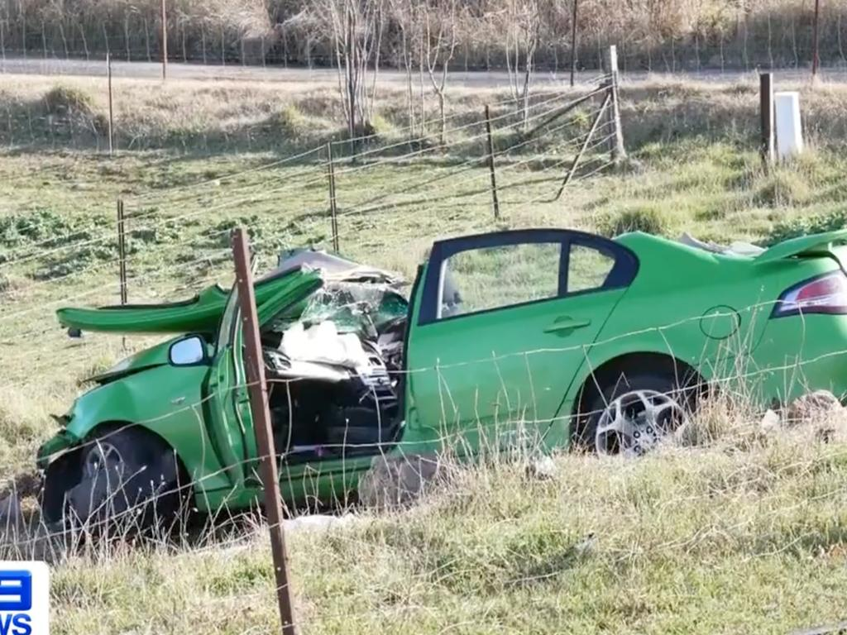
Kristy Armstrong died instantly when police said she was run off the road at Molong. Picture: 9 News
But a close friends of Mrs Armstrong, who worked as a medical receptionist, said the AVO in place did nothing to protect the “adoring mother of three little girls”.
“What is it even worth, it’s a piece of paper really, you know, just useless,” one friend said.
“We are just distraught … Kristy’s life was her kids, there’s no better mum on this earth than Kristy.”
Two young girls who were passengers in Mrs Armstrong’s car, aged 13 and 8, were taken to hospital with minor injuries. They are now being cared for by their grandparents.
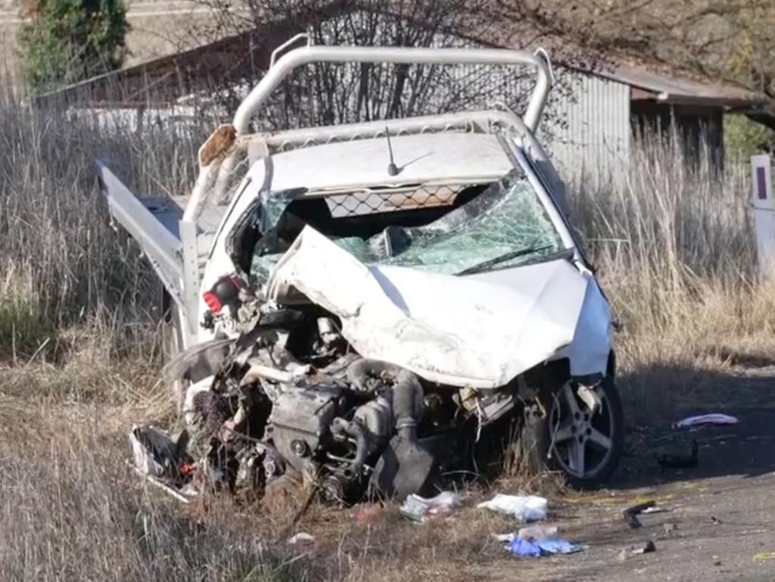
Troy Armstrong was pulled from his mangle utility and taken to hospital where he remains in a serious condition under police guard. Picture: 9 News
The Molong and nearby Orange community, where Mrs Armstrong grew up and was well-known, is now reeling from the tragedy.
“It is with the heaviest of hearts that we let our softball community know one of our own, Kristy, passed away yesterday. We send our deepest sympathies and lots of love to her family at this very difficult time. RIP Kristy,” the Orange District Softball Association posted.
A NSW Police spokesman said detectives were waiting until Mr Armstrong’s condition improved before he is interviewed.
Domestic violence prevention minister Jodie Harrison said while the incident remained a matter for the police, the death of yet another young woman was devastating.
“It is a tragedy that another young woman has lost her life and my thoughts go out to her family and her children who have lost their mum,” she said.
“The issue of domestic violence is one for all of us to take responsibility for, not just politicians and police.”

